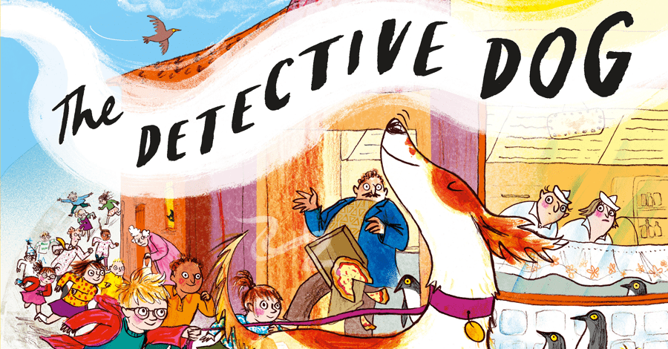
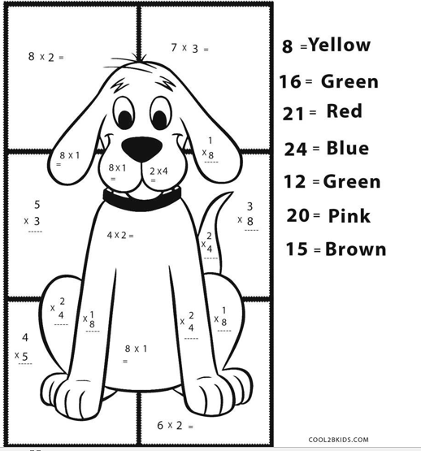
Can you complete the maths to work out how to colour Nell?
Use objects if that helps.

