
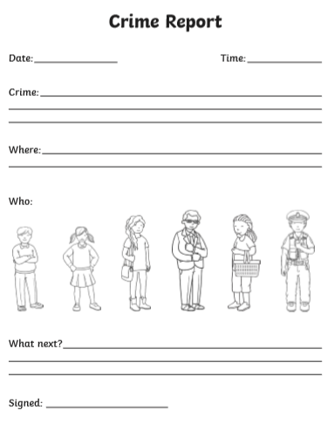
Listen to the story again (see YouTube or the PowerPoint I uploaded). Can you fill-in this crime report?

