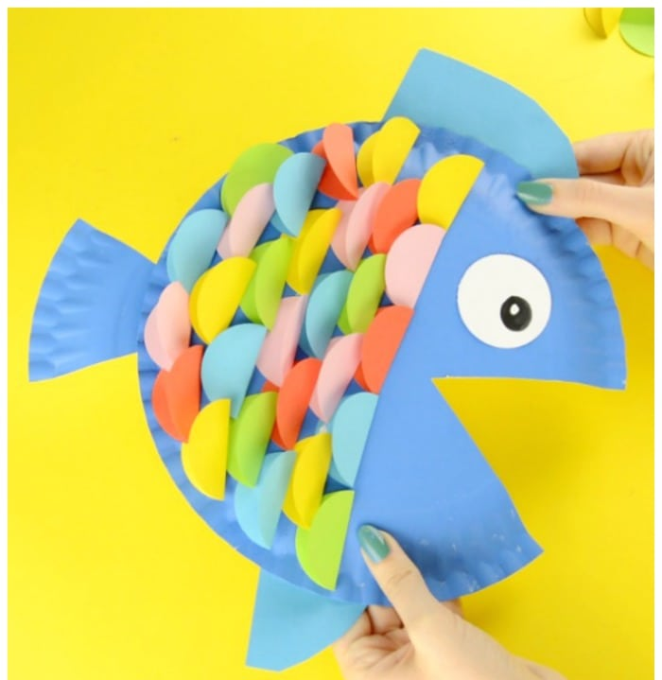
- Look at this Rainbow Fish craft. How do you think you make it? What will you need? Share your ideas with an adult.

- Have a go at making it.

- Can you type the instructions on J2e on HWB?

