Rainbow Fish Cooking

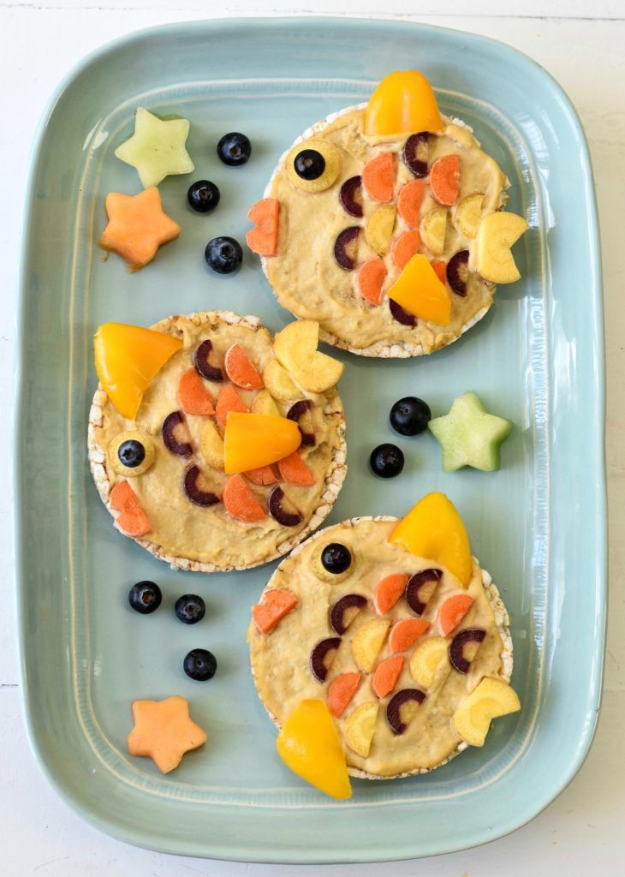

What you’ll need to make these Fishy Rice Cakes:
- rice cakes
- hummus
- multi-coloured carrots, sliced
- pepper
- blueberries

To make each rice cake:
- Slather 1 Tbsp. of hummus over the rice cake.
- Place the sliced carrot halves in place of the scales.
- Create 3 carrot slices: 1 for the fishy lips, 1 for the tail, and the other for the eye.
- Place a blueberry over the carrot eye.
- Slice a pepper and place for the fins.

