The families’ resources are located here -
http://www.snapcymru.org/coronavirus-information-and-resources-for-families/

ALN education update in response to family and professional queries
http://www.snapcymru.org/coronavirus-and-additional-learning-needs-update/

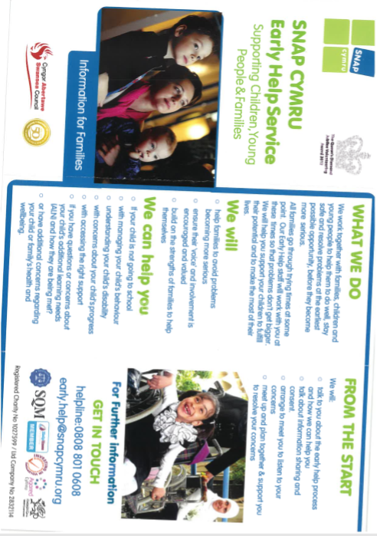
Resources: Interplay’s Stay Safe, Stay at Home Provision

Activities from I Can a charity that helps children communicate: https://ican.org.uk/about-us/

- If you can’t bring your children to the zoo, why not bring the zoo to them? Some zoos are livestreaming their animals to people around the world – have a look at Melbourne Zoo, Marwell Zoo, Edinburgh Zoo, and Chester Zoo https://www.streamdays.com/camera/view/chester_zoo.
- Widget are offering free unrestricted access to Widget Online for 30 days, to make sure that symbol users have access to the systems and resources they need.
- Ruth Miskin is live streaming RWI phonics lessons for parents to do at home with children.
- The Drama Geezers are sharing a drama activity a day on their YouTube channel and website – some of these are great for encouraging speech, language and communication skills as well as being fun!
- Here is a handy resource that can be used in an indoor treasure hunt to help children learn new vocabulary and concepts – or make your own up!
- Audible are offering free unlimited streaming of hundreds of stories for children and families; a great way to encourage a love of stories in children who find reading difficult.
- The Speech and Language Therapists at I CAN’s Dawn House school are sharing a Makaton story every day for children with speech, language and communication needs – find them each day by following I CAN’s Twitter feed. View the first one (Goldilocks and the Three Bears) here.

Resources: …to help children understand coronavirus
- In this video, Speech and Language Therapist Alex Kelly explains (with Makaton) what coronavirus is, and what the current advice is around it. A good resource for children with and without speech, language and communication needs, and people with autism or learning difficulties.
- Here is a helpful story that can be used to explain coronavirus to children, and this story with visual supports can help explain what might happen if people need to go to hospital.
- To reassure young children who are anxious or worried, try reading them this story about Dave the Dog who is worried about coronavirus.
- For older children, this social story from Carol Gray can help to explain pandemics and the coronavirus.
- Talking Mats have produced this handy visual support to help explain social distancing to people with communication difficulties (but can also be helpful for explaining to children as well).
- This visualisation about coronavirus can be used to support older children to understand why we are being told to stay at home during this time, as it shows each person spreading the virus to another 3 people if they don’t stay at home.

