EMPATHY WEEK: Countdown to Empathy Day!
@EmpathyLabUK #EmpathyDay
If we were in school, this week would be our EMPATHY WEEK. We would be taking part in activities that help us understand what the word empathy means and showing empathy for story book characters in different ways.
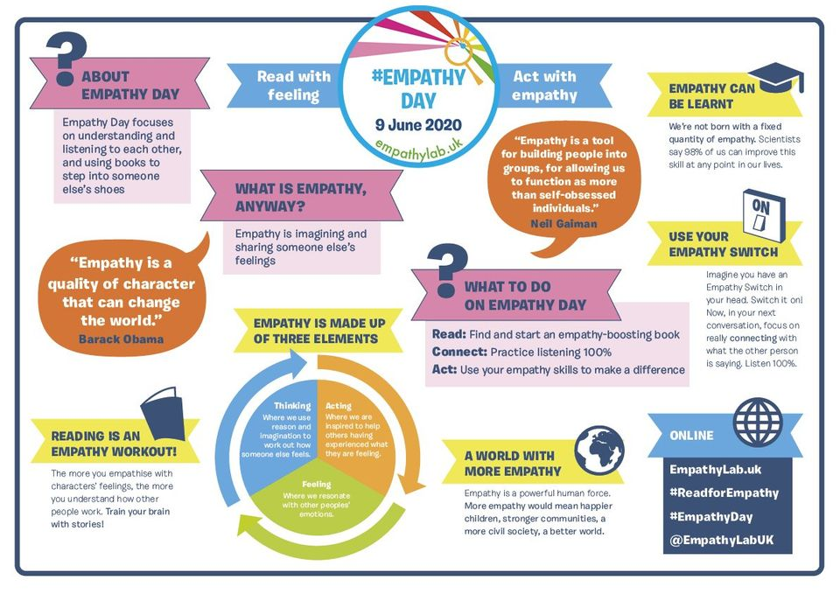
You can still do some of these activities at home. There are some ideas that will help you on the Empathy Lab website.
https://www.empathylab.uk/
Click on the tab at the top that says ‘Empathy Day’ and select ‘Family Activities Pack’ from the drop down menu.
If you can’t access them there you can find them in the News and Events section on our school website.
http://clwyd-cps.secure-primarysite.net/empathy-day-june-9th/
You can download the pack from there. Feel free to try any of these this week but I will be choosing one for you to do each day and this will be on our class page.
There are some stories in the ‘Empathy Read Aloud’ section that you could use to help you complete the activities. Again, feel free to listen to any of these but I have listed the ones that I feel are most suitable for Foundation Phase children.
Elmer’s Birthday
The Steve’s
Super Duper You
We have really enjoyed seeing the pictures that you have sent us of your home learning and would love for you to take some showing what EMPATHY WEEK activities you have completed.
Thank-you!

