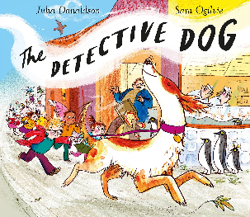
Clever Dog!
Nell used her brain as well as her nose to solve the crime.
Use your amazing brain to solve the Maths work.

Cut the squares out and match them with the rectangles answers. DO THE ONES YOU KNOW FIRST.
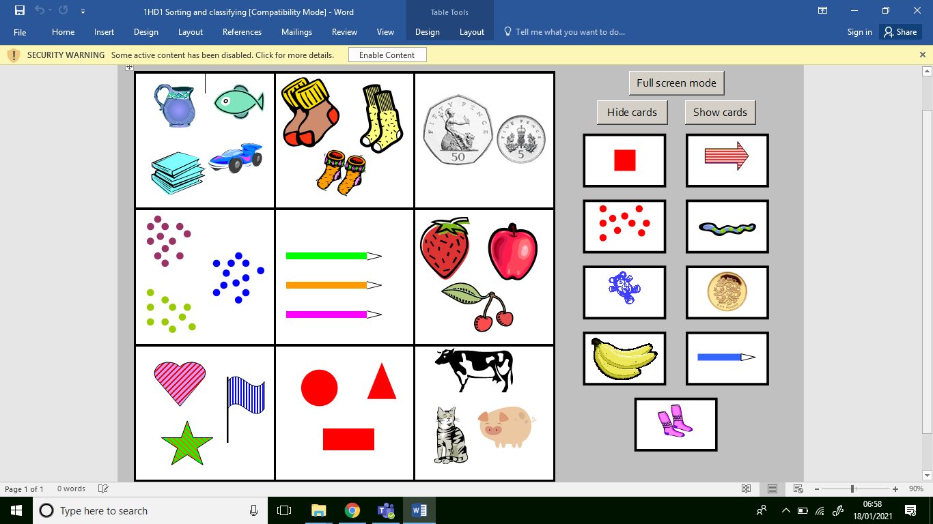

Clever Dog!
Nell used her brain as well as her nose to solve the crime.
Use your amazing brain to solve the Maths work.

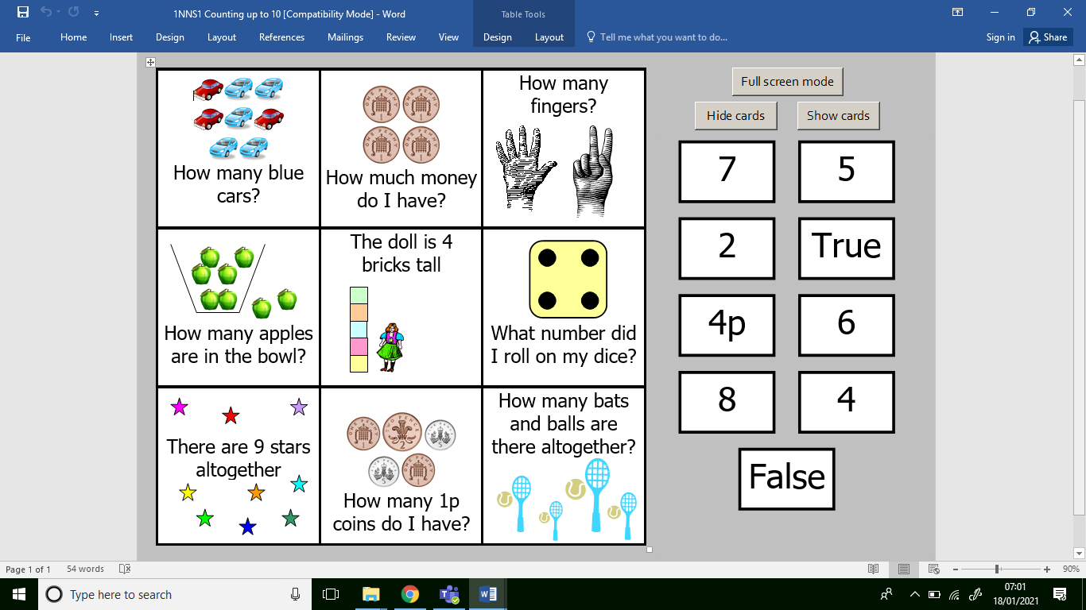
Cut the squares out and match them with the rectangles answers. DO THE ONES YOU KNOW FIRST.

Clever Dog!
Nell used her brain as well as her nose to solve the crime.
Use your amazing brain to solve the Maths work.

Cut the squares out and match them with the rectangles answers. DO THE ONES YOU KNOW FIRST.
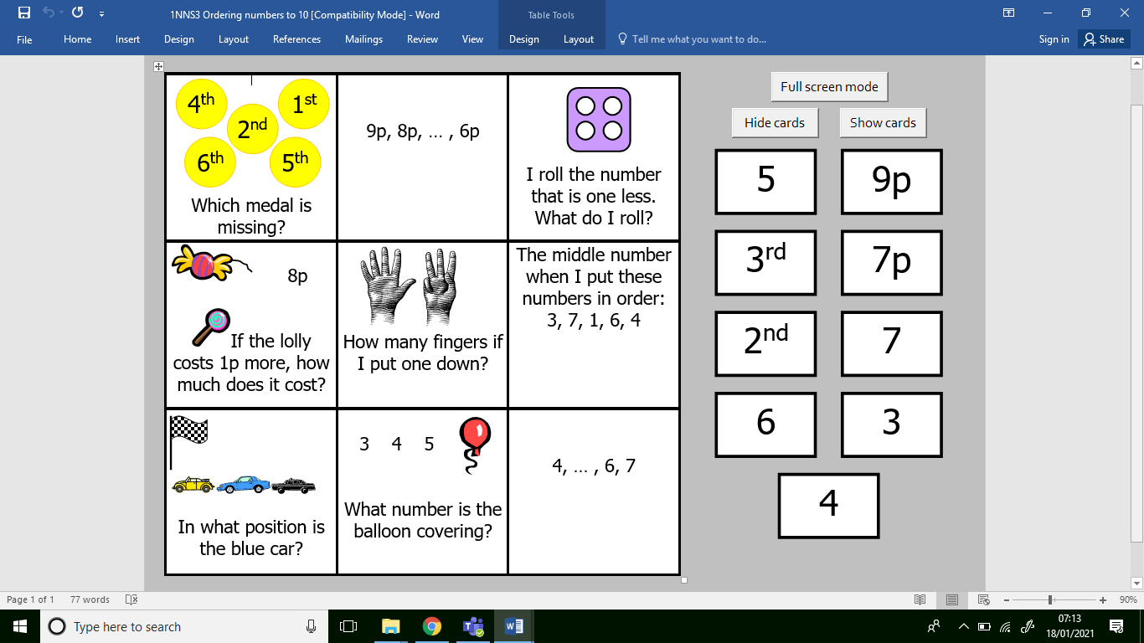

Clever Dog!
Nell used her brain as well as her nose to solve the crime.
Use your amazing brain to solve the Maths work.

Cut the squares out and match them with the rectangles answers. DO THE ONES YOU KNOW FIRST.
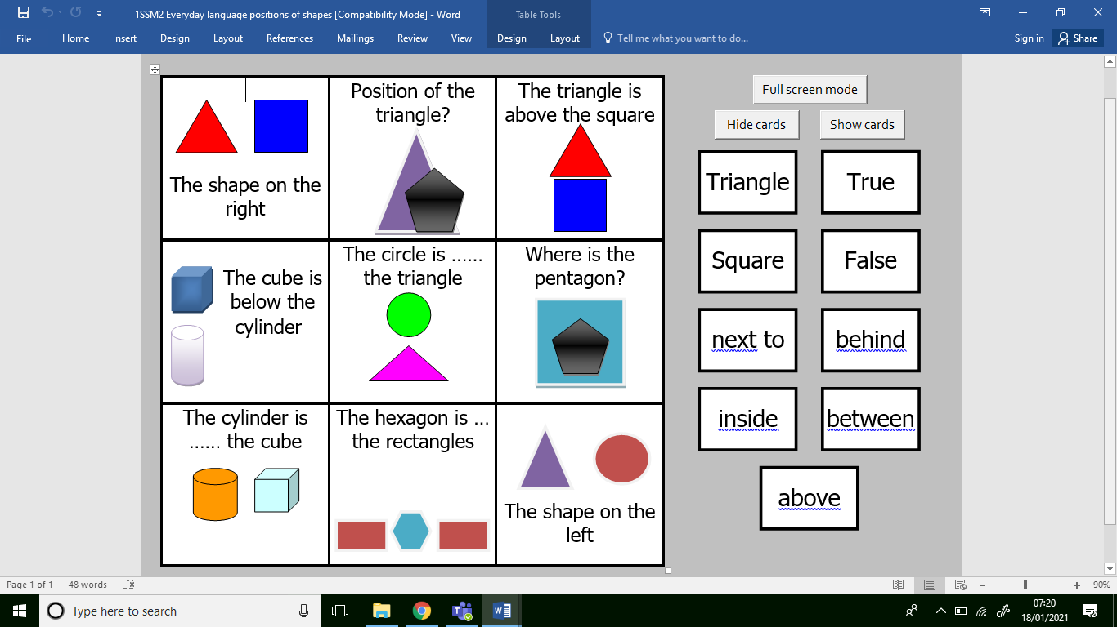

Clever Dog!
Nell used her brain as well as her nose to solve the crime.
Use your amazing brain to solve the Maths work.

Cut the squares out and match them with the rectangles answers. DO THE ONES YOU KNOW FIRST.
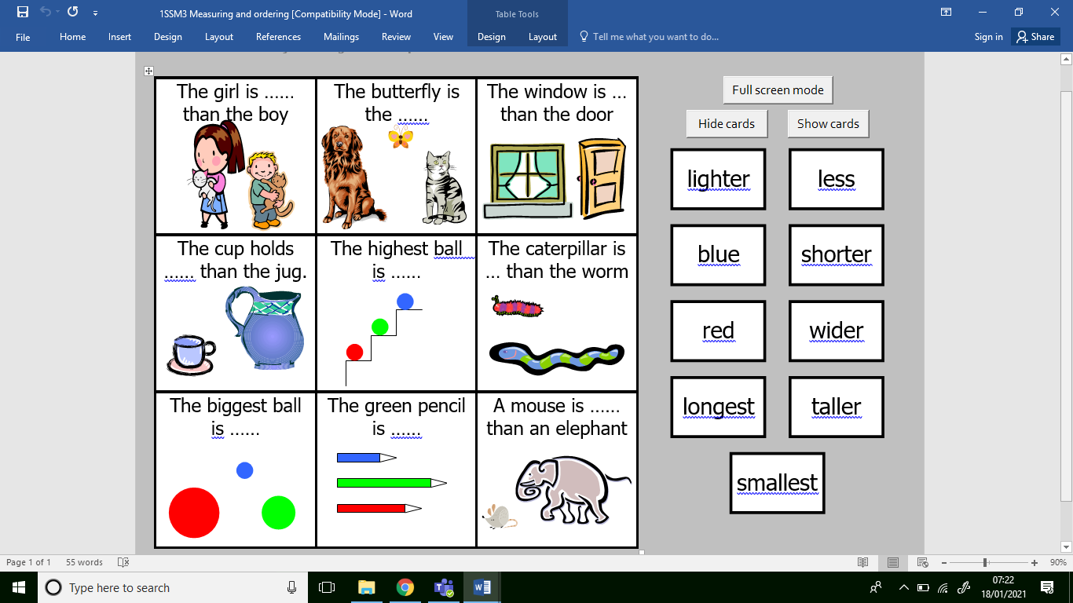

Clever Dog!
Nell used her brain as well as her nose to solve the crime.
Use your amazing brain to solve the Maths work.

Cut the squares out and match them with the rectangles answers. DO THE ONES YOU KNOW FIRST.
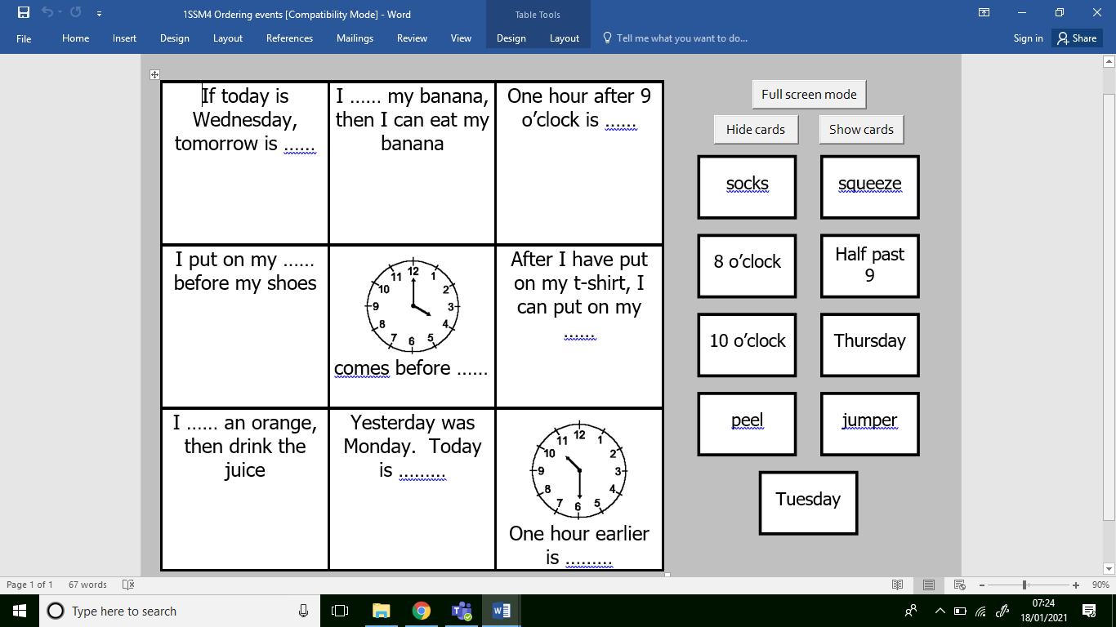

Clever Dog!
Nell used her brain as well as her nose to solve the crime.
Use your amazing brain to solve the Maths work.

Cut the squares out and match them with the rectangles answers. DO THE ONES YOU KNOW FIRST.
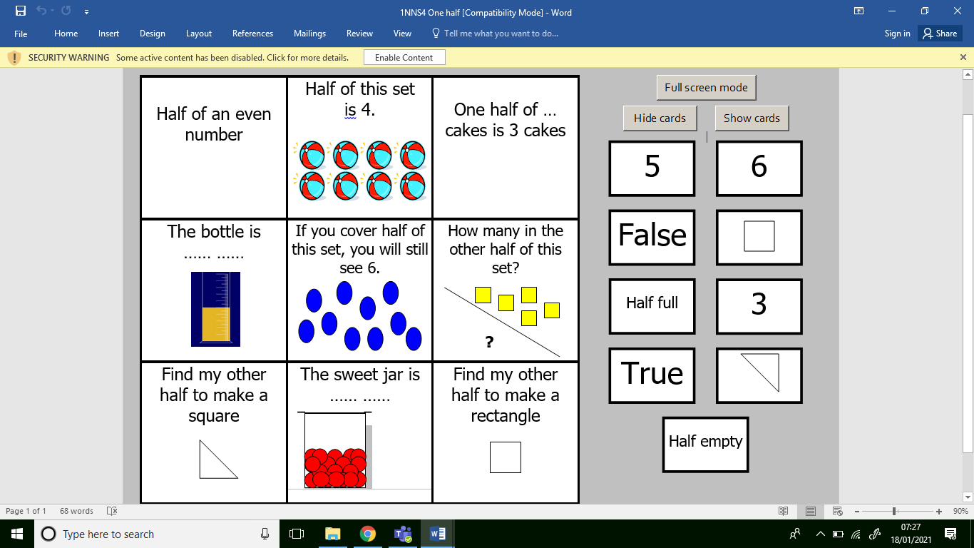

Clever Dog!
Nell used her brain as well as her nose to solve the crime.
Use your amazing brain to solve the Maths work.

Cut the squares out and match them with the rectangles answers. DO THE ONES YOU KNOW FIRST.

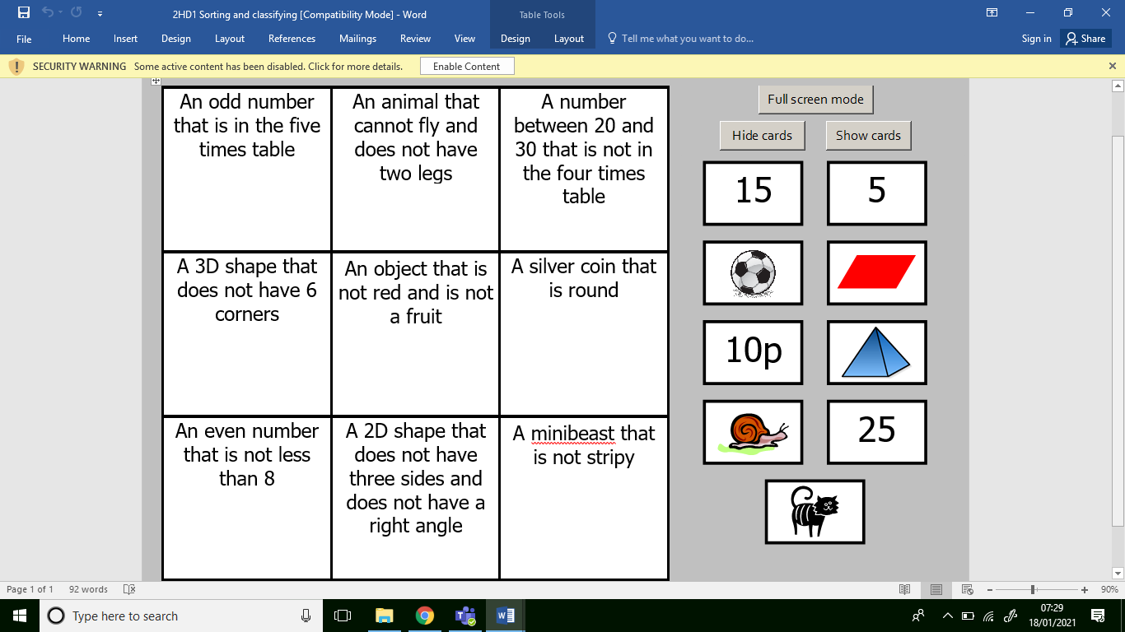

Clever Dog!
Nell used her brain as well as her nose to solve the crime.
Use your amazing brain to solve the Maths work.

Cut the squares out and match them with the rectangles answers. DO THE ONES YOU KNOW FIRST.



