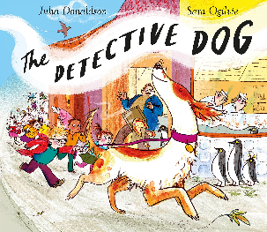
What's that smell?|
Nell used her sense of smell to find the book thief. Take part in a smell competition with your family! Use a blindfold for the 'smeller' and see how many they get right! Please take photos of the game and share on Dojo!

Smell | Did you guess it?
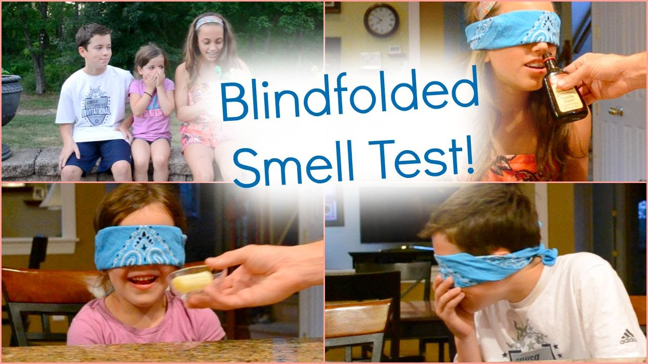

Who has the best sense of smell in your house??

