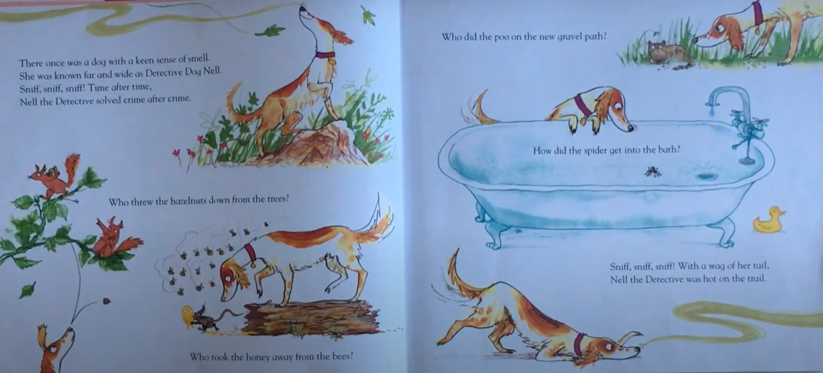

- Colour in words that sound the same (rhyme)
- Write the rhyming words below
- Can you think of another word that rhymes? Write this in the grey column
smell | Nell | fell
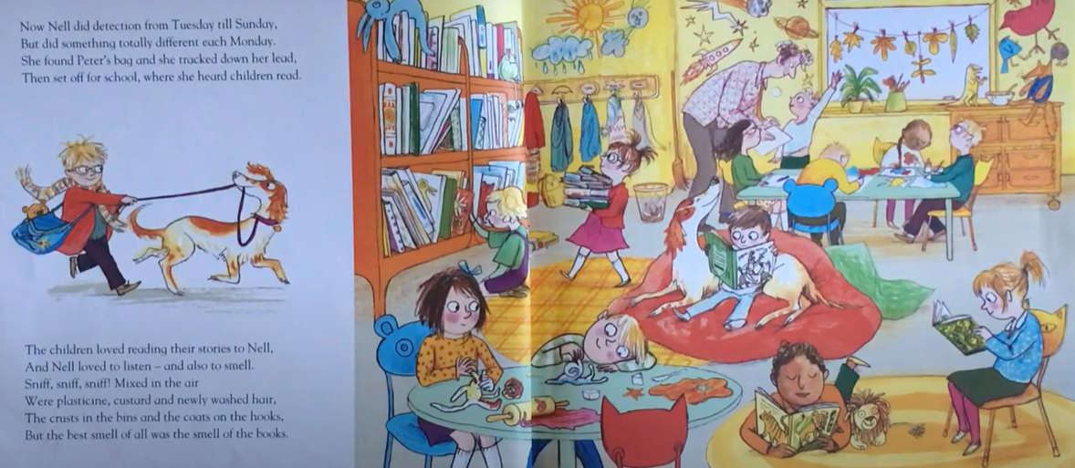

- Colour in words that sound the same (rhyme)
- Write the rhyming words below
- Can you think of another word that rhymes? Write this in the grey column
Sunday | Monday | Friday
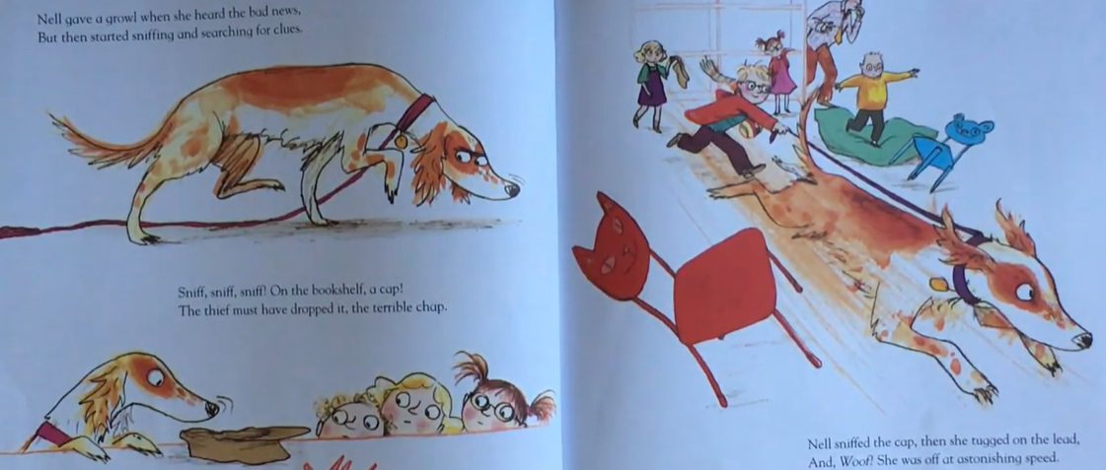

- Colour in words that sound the same (rhyme)
- Write the rhyming words below
- Can you think of another word that rhymes? Write this in the grey column
news | clues | shoes

