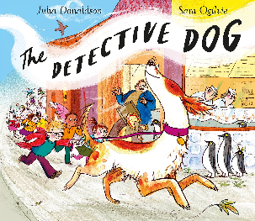

Reading Time
Nell finds Ted reading books. They end up going to the library, enjoying lots of books!
Make yourself your very own reading corner. Make it comfortable and snug. Please share a photo of it on Dojo. Enjoy reading some books! (On your own or with an adult)
Please also continue with Reading Eggs.

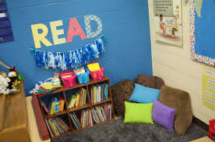

Title of book | Did you like it?  Please score out of 10

