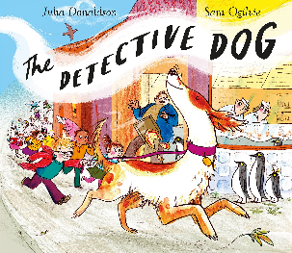

Police Dogs
The police use dogs like Nell to sniff out clues and help to solve crimes. Please find out about Police dogs and make a poster. You could make it on J2e5 (on Hwb) or you could create one using paper and pens. You poster will need
-A title
-pictures
-writing
-colour
Think about the type of dogs, their training, their job, their food, their rewards, their ages etc.


