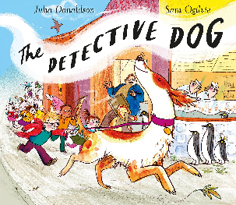

Fit as a butcher's Dog!
Nell needs to be able to run fast to be able to solve the crime and catch the thief. Set-up a fitness course in your garden or down the park. If you have a dog, see if you can get him/her to run the course. Then have a go yourself. Do it 5 times, recording your times. Which was your fastest?

Attempt | Time
1
2
3
4
5
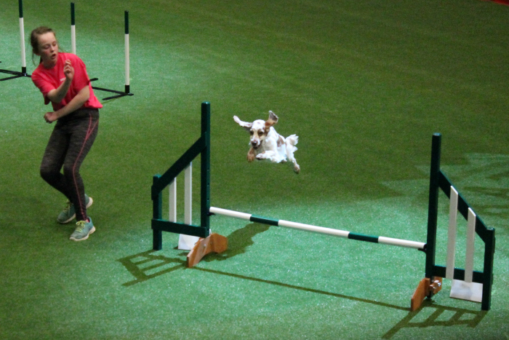

Which was your fastest time?

