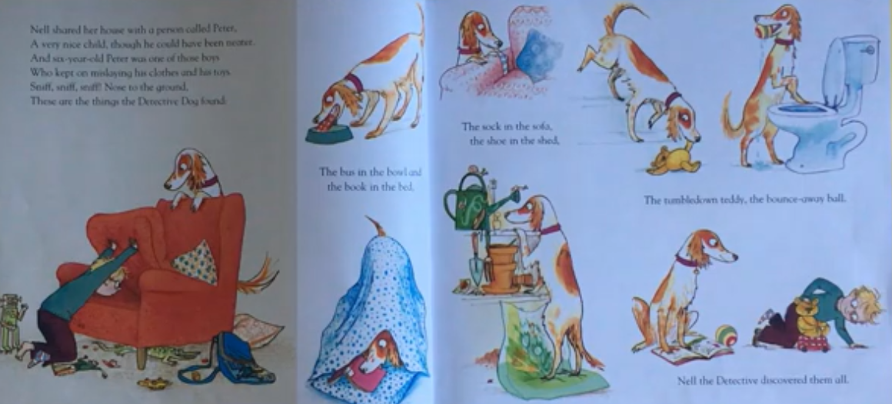
Peter

Peter was a bit messy. He didn’t tidy-up and he kept losing things!
Your mission is to tidy your room!
Please write down/draw anything you find which you hadn’t seen for a while.

