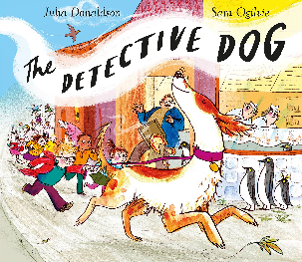

Good Dog!
Nell was a good dog and she used her brain to solve the crime. Please make her a certificate. Please use J2e5 on HWB. If you prefer you could make it on card or paper instead. Here are examples of what certificates are:



