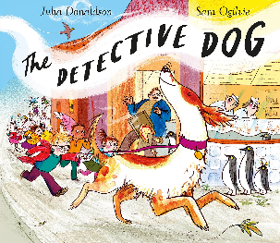

Doggy Drawing
Nell is a long, slim, fast and scruffy dog. Draw your own dog. You can use the template below to help if you’d like.



