BEHAVIOUR | CONSEQUENCE
  Being kind  Being helpful  Tidying up  Sharing  Saying please  Saying thank you  Saying nice things  Listening  Following instructions  Doing your work  Walking away instead of hitting  Showing self-control | - Dojo points  - Special Mentions  - Extra ‘free time’  - Parents informed  - Show Mr Brown (HT) your work  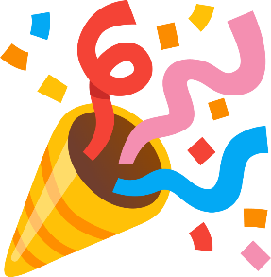  - Praise  - I-pad time  - Reward shop  tokens
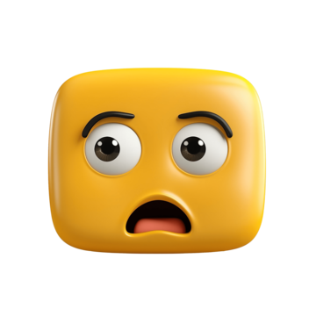  Swearing  Being unkind  Calling others names  Shouting at others  Hitting others  Not following instructions  Not doing your work  Not sharing | - Spending some time away from the other pupils.  - Missing out on activities  - Parents informed so that behaviour can be talked about at home.  PLEASE SAY SORRY AND TRY AND REPAIR ANY DAMAGE
  Consistent or serious assaults  on pupils or staff.  Significant damage  to property. | Behaviour that ‘crosses the line’ will mean that you have to go home.


